Assignment 8:

Using clipping mask technique insert an image within a shape.

Before image:



Steps:

* open the image
* Select image layer (marked as background), Go to layer option, go to new, select layer from background, Set the background image as layer0.
* Select the ellipse tool (or any other custom shape tool, left menu list) and select the portion of the image that is to be clipped, this will create an ellipse layer.
* Now, go to layers list and drag the ellipse layer below the layer0 (image layer) to get the image behind the ellipse.
* Right click on layer0 and select clipping mask.

After image:



Assignment 9:

Place an image inside a text and apply multiple effects on the text like stroke, drop shadow, bavel emboss, gradient overlay. (need before after for each effects)

Before image:



Steps:

* Open the image
* Select the text tool
* Make text box
* Type a text according to your choice
* Set the text size, align, change font, color if needed.
* Select image layer (marked as background), Go to layer option, go to new, select layer from background, Set the background image as layer0.
* Now, go to layers list and drag the text layer below the layer0 (image layer) to get the image behind the text.
* Right Click on layer0 (image layer) and select “set clipping mask”.
* Select text layer.
* Go to “add layer style” (bottom right, fx) and add styles to the text.

After image (image as text background):

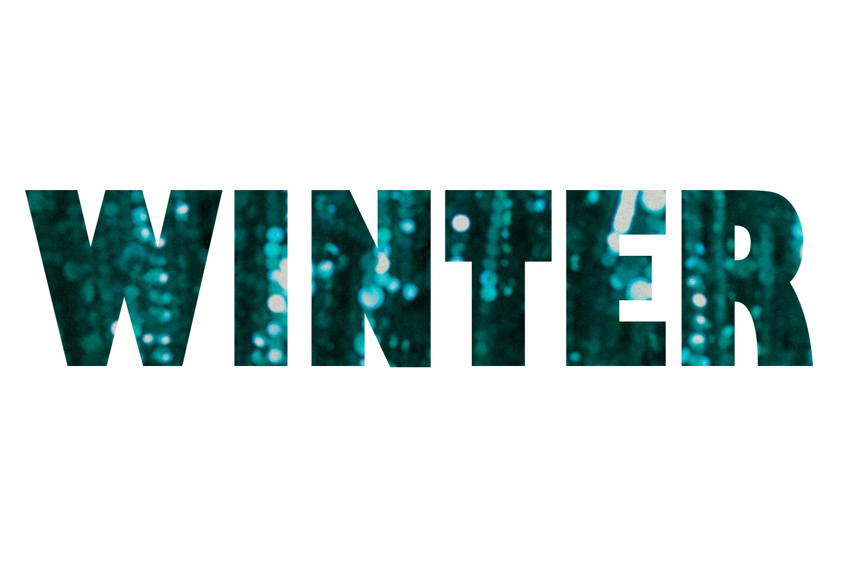

After image (stroke):

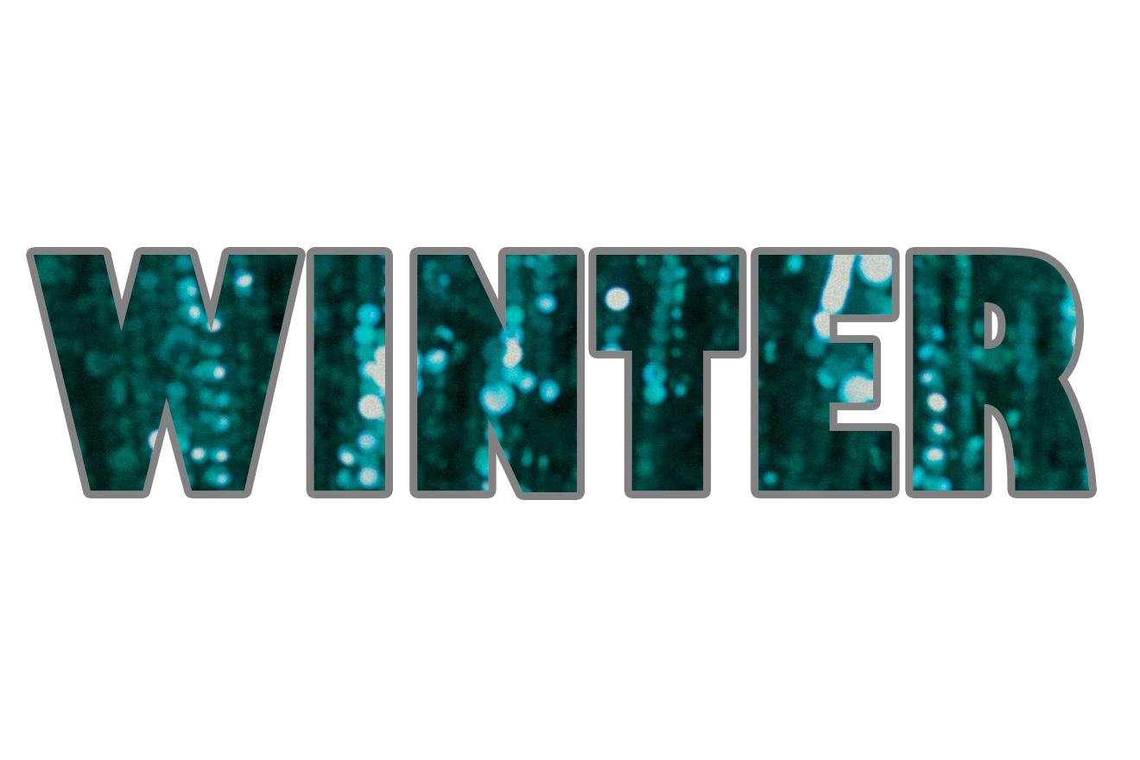

After image (drop shadow):

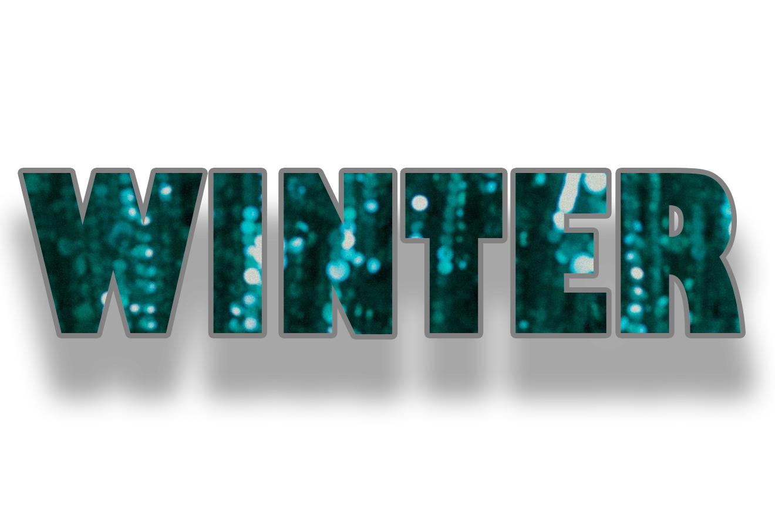

After image (bavel emboss):

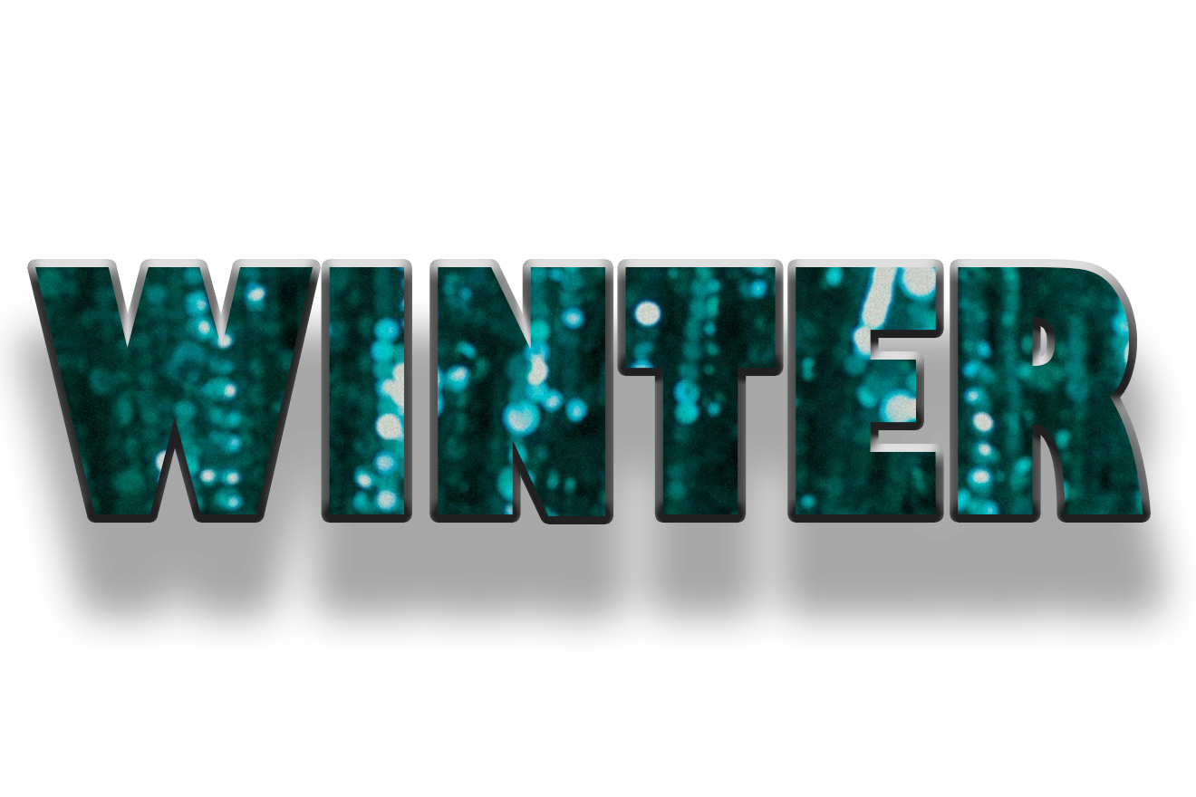

After image (gradient overlay):

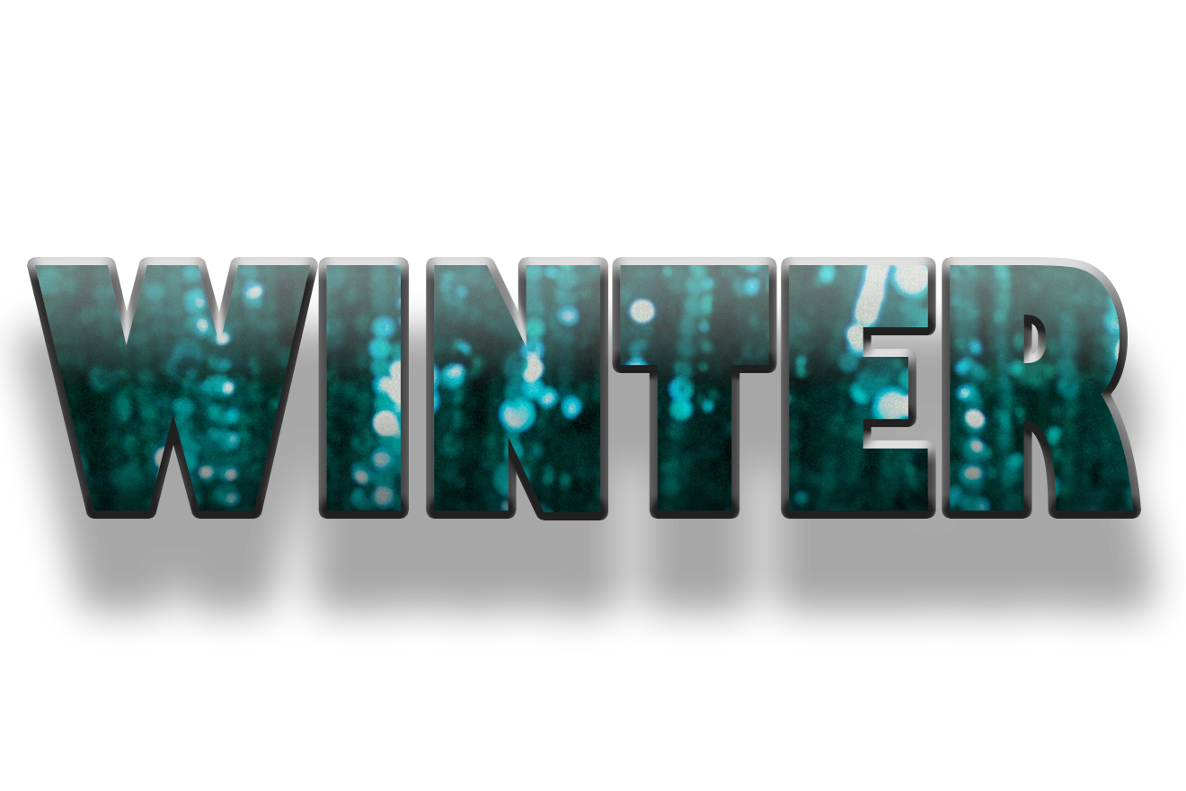

Using different Bavel Emboss:

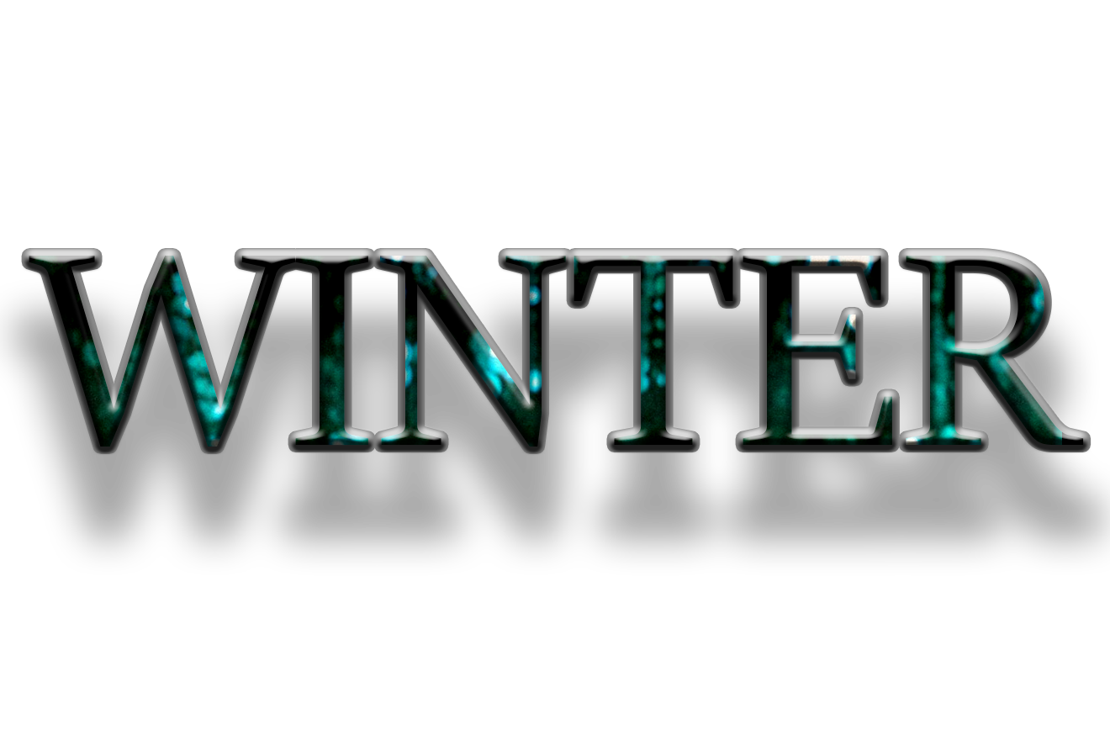

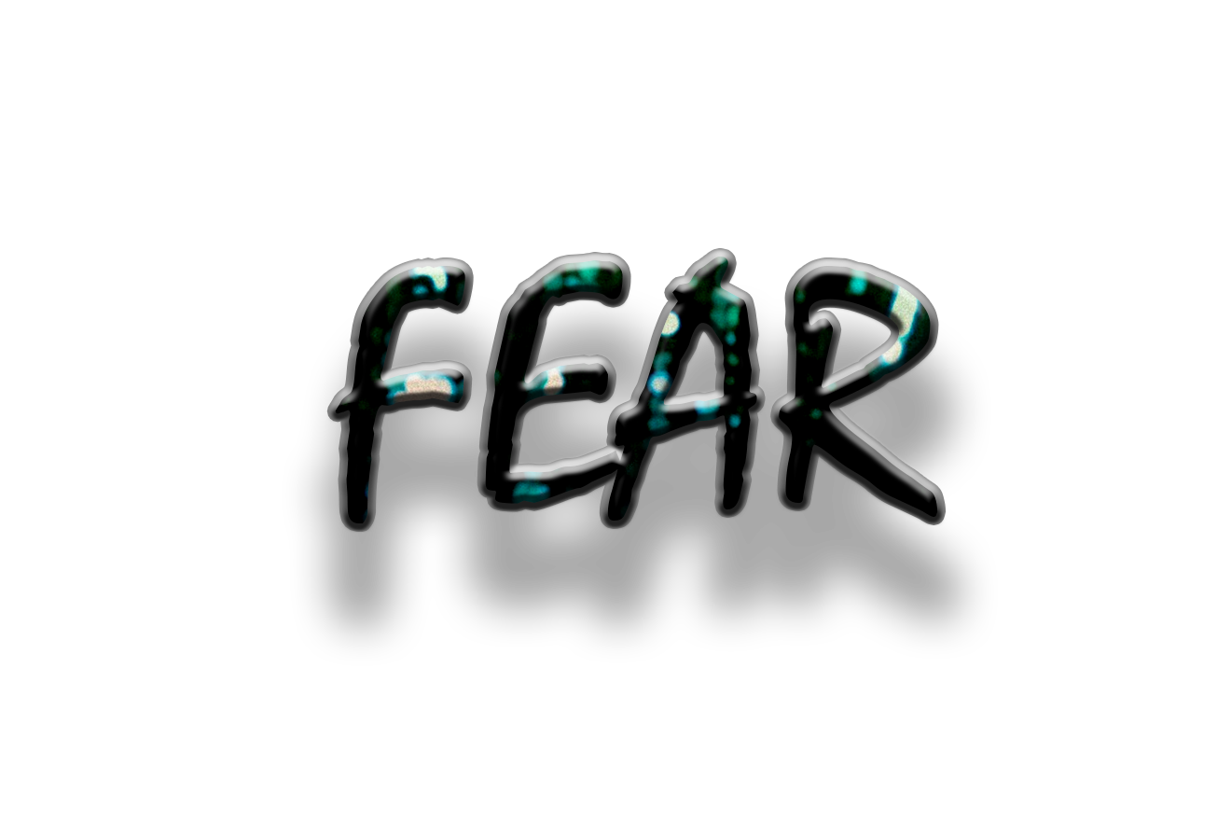

Assignment 10:

Use mosaic filter on the image.

Before image:



Steps:

* Open the image.
* Goto filter, select Pixelate, select Mosaic.
* Set cell size, ok.

After image:

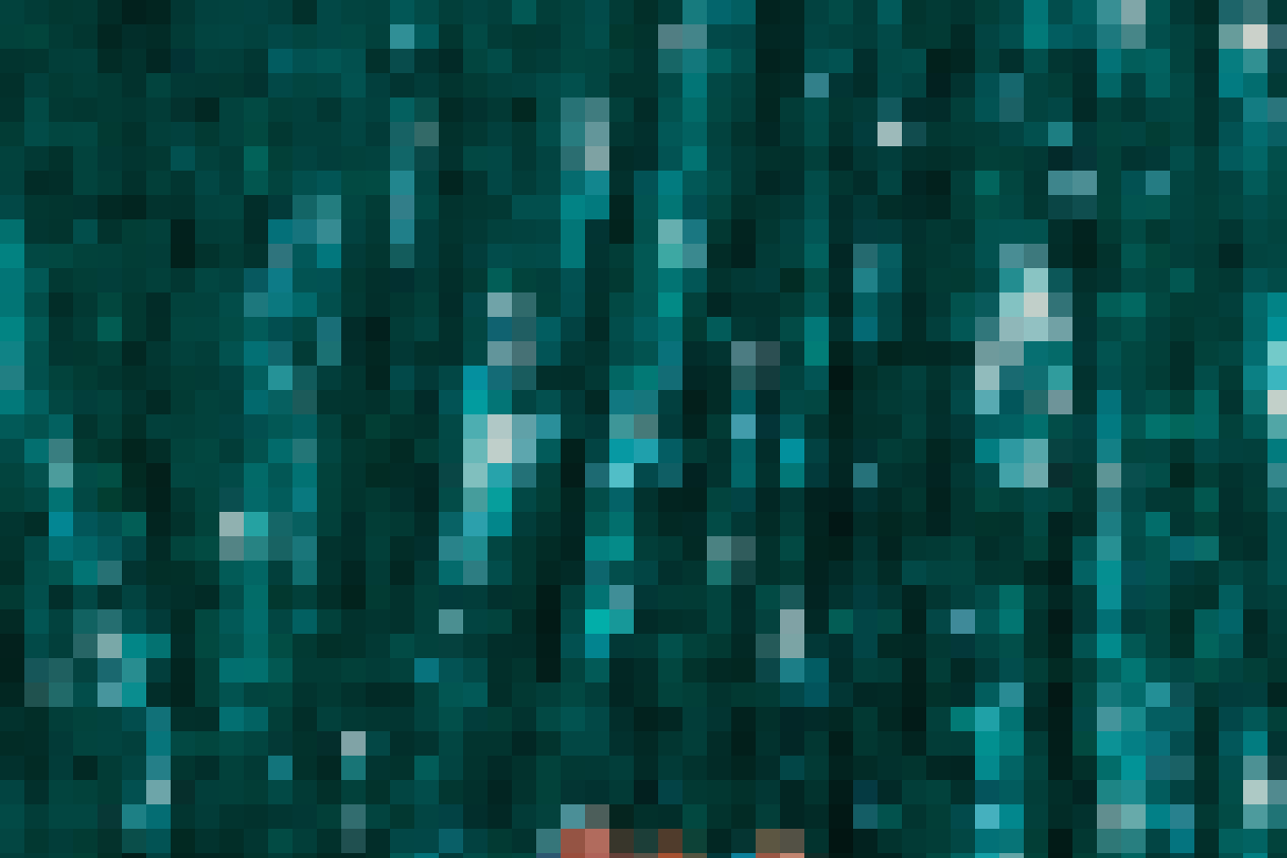

Assignment 11: Add a frame to the image.

Before image:

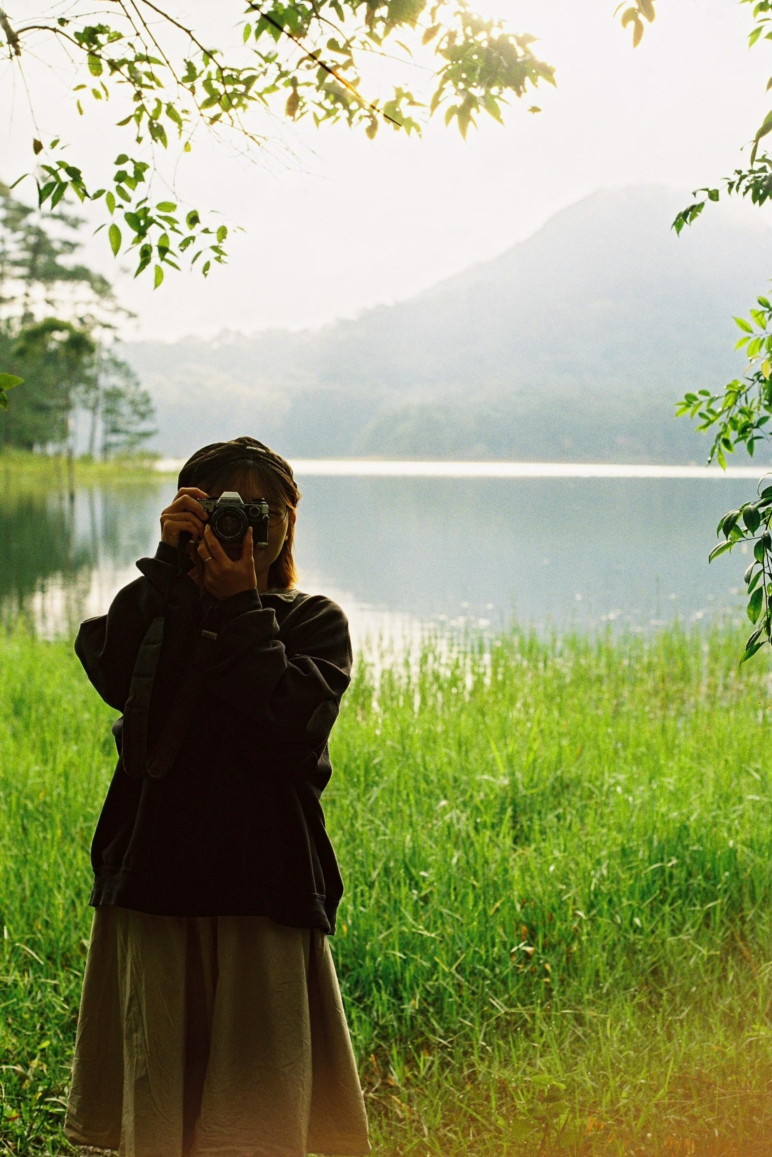

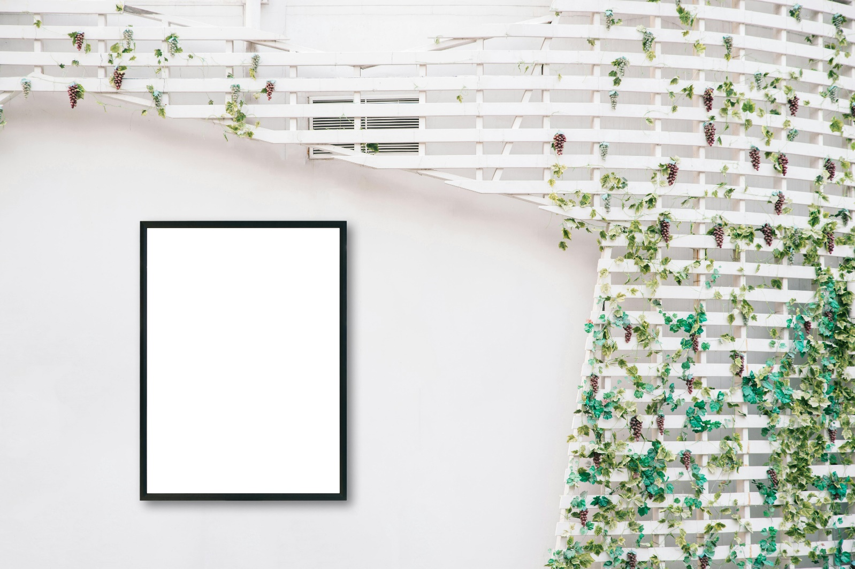

Steps:

* Open the frame and the image.
* Crop the image to fit it into the frame, if needed.
* Select the image by move tool and drag it on the frame tab and place it on top the frame area, it will become a new layer, say “layer1”.
* Select layer1 (the image layer).
* Select “Rectangular Marquee Tool” and right click on the image and select free transform.
* Change the image size as needed to fit the image or its desired portion inside the frame.
* Select background layer, and turn off the visibility of layer 1 or image layer.
* Use magic wand to select the area of the frame where we put the image.
* After selection, make layer 1 visible (without selecting it), to get a preview of how much image falls in selected area on the frame.
* Go to select -> modify, use contract or expand to contract or expand the selected frame area, to fit the image properly into the frame.
* Select layer1 (image layer) and click on “add layer mask” (bottom right).
* Save your master piece.

After image:

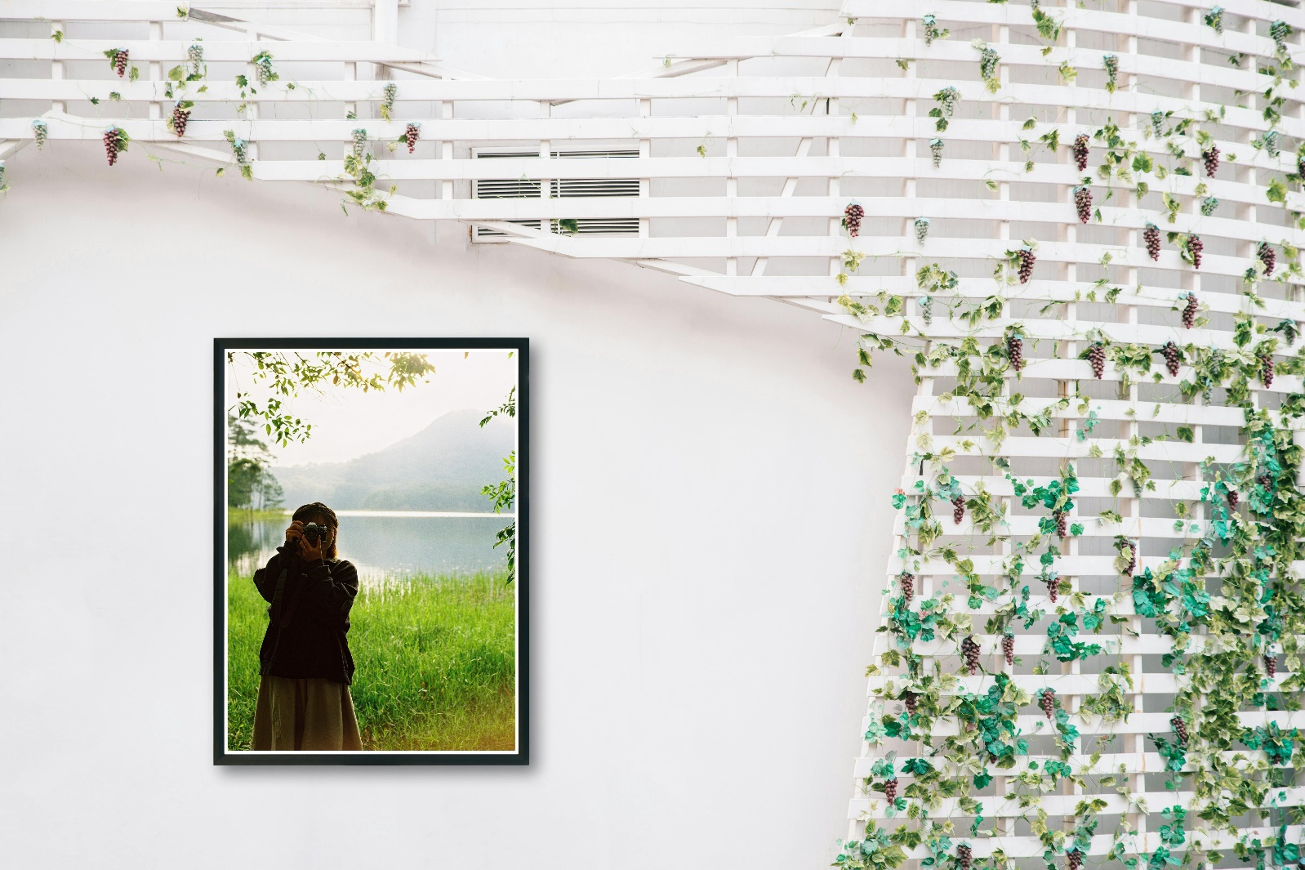

Assignment 12: Banner design for cultural event of the college.